ISS 2018 Würzburg

Monday
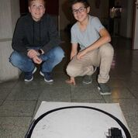
My story starts at six o'clock when my alarm clock started beeping. I got dressed and had breakfast. There was a lot to eat, but I chose müsli with milk. After breakfast we went to the bus station and got on the bus. The driver was driving so fast. During the walk Jonathan (my exchange partner and friend) told me I can't use my phone. This surprised me a lot.
Firstly we had to fill in some phantom information into a witty paper. After this, science began!
First experiment: efficiency of a heat pump- two aluminium cubes, one down and other one on the top. As the top one was getting hotter, the other one was getting colder.
At half past twelve we had lunch in the school canteen. In the last part of the Monday programme, we visited The Institute for Horticulture and Viniculture. There we talked about positives of plants in city. After dinner, Jonathan and I watched Doctor Strange from marvel. I, of course, took a shower, brushed my teeth, and fell asleep full of experience, emotions and food:-).
Matěj Vošmik

Tuesday
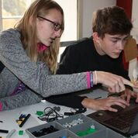
This morning we met at school at 8 a.m. and we started doing experiments with energy again. We tried to transform light energy to drive a fan with help of a flashlight and a solar panel. After we hade made it work we put a glass between the flashlight and the solar panel and we were measuring the impact to the speed of the fan.
Then we were trying to find out the biggest possible distance between the source of energy and the appliance that would still keep it moving.
Before lunch, we were watching a documentary about climate changes, global warming and bad influence of people on the planet. Through the whole documentary Leonardo DiCaprio was guiding us like a messenger of peace and like an environmental activist.
We had lunch in the school canteen and then, like every day, we played football at the school sports ground. When we were tired we went on foot to visit a UNESCO monument, the Residence. First of all we went to the beautifully coloured gardens and then we went to the interior of the Residence.
We started our visit at the staircase upon which the biggest ceiling painting in the world is situated. Then our steps took us to the White hall, Imperial hall and to the Mirror hall. At the end we had a look at paintings of some well known artists of the world and we stood again under the ceiling painting.
This was the end of our common part of this day. Everyone went home with their hosts but the hosts of the British students had to pick them up at the train station.
I really enjoyed this day. It was fun to do the experiments and we also learned something about the history of Würzburg.
Adéla Hrudková

Wednesday
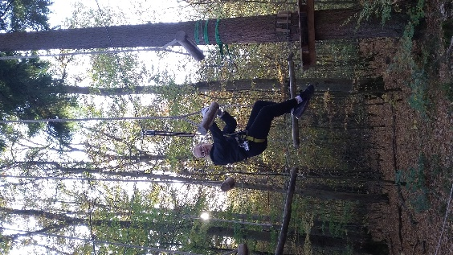
My day started as usual, in front of fireplace. Wednesday was the first day of robotics. We were divided into 6 groups of 2 German, 1 Czech and 1 English student. Each group got a laptop, manual, worksheets and a box full of little pieces of Lego Mindstorm. First, we had to turn on our laptops, and then turn on an application for programming our robots. Then, each group got a tower to connect RCX to the computer. RCX was like a heart of our little robot. After that, Mr. Völker instructed us how to program robots. In the afternoon, we went bowling. It was really funny. In the evening, my host Eva took me to her gym wheel training. It was hard, but it was really cool and it was a new experience for me. That’s all from Wednesday at ISS 2018 in Würzburg.
Katka Pánková

Thursday
On Thursday, we did many things.
We woke up at seven o'clock. The rest of the family were already having breakfast, so we joined them. We had a plain croissant with scrambled eggs. We got to school by bus. I was very surprised, because in Germany they got really expensive tickets.
We played soccer with some German guys before the school started. In school we completed some programming tasks given to us by Mr. Völker and afterwards we created and programmed a robot, that could fetch us something. Then we went for lunch to the school canteen.
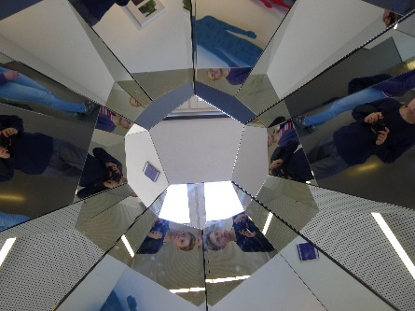
After lunch, we went to another part of the city, where the next activity took place. We got to bouldering by bus. On the way to bouldering I became friends with Ben from England.
All of us enjoyed the bouldering. I got to the city with my friends by bus and from there I walked with my exchange partner about 10 km through the city back home. I had dinner and then we watched some anime. I went to sleep really tired after such a busy day.
Eduard Bičiště

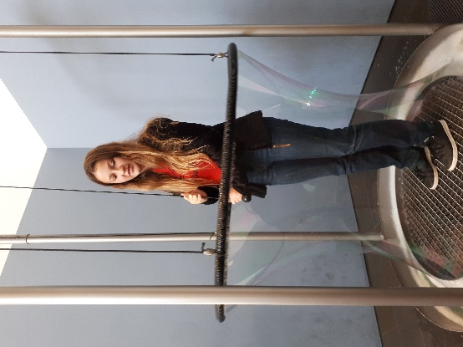
Friday
This day started like the others… l woke up at six o’clock but I was lying in my bed till half past six, I brushed my teeth, I brushed my hair and ran with my Germany friend to the tram stop at seven o’clock. The journey took twenty minutes and then we had to change vehicle so the rest of the way we spent on the bus. The program started at eight o’clock. Friday topic was robotics with Mr. Völker. The most important task was to program the robot to fight. After robotics, we went sightseeing in Würzburg. One of the sights which we saw was Marienkapelle. Then we came back to the grammar school, where we did sport activities. The first task sounded something like this: everyone must stand on the blanket and you must turn the blanket upside down. My team lost but I didn't care, it was fun. The second task sounded like this: sit in a circle and do boom - boom - snap your fingers - snap your fingers and on the first snap of your fingers you must say your name and on the second snap of your fingers you must say the name of somebody else. And the last one was parkour. I was scared of it but after that I told myself that I had fun. And I finished the day with well - earned sleep.
Eliška Turková

Saturday
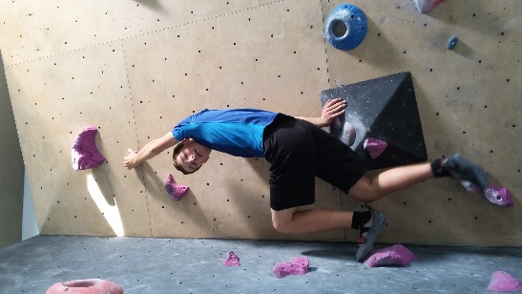
At 7:15 a.m. we took a train to Hanau. In Hanau we had to change the train to Gießen.
Around 10:00 a.m our visit of Mathematikum started. Mathematikum is an interactive centre of math. We could try and discover everything on our own. There were more than 200 experiments about for example curves, π, geometric shapes, 3D puzzles, infinity and Fibonacci sequence. Then we had lunch with our exchange partners in the city centre. We were discovering Asian and Indian food. In the afternoon we were played a sightseeing game in groups there. We had to answer questions using tourist information signs in the centre of Gießen.
After one hour we had to go to the train station and go by train to Bad Nauheim. In Bad Nauheim we changed the train to Hanau and there we went by train back to Würzburg, where we arrived at 7:30 p.m.

Jakub Ježek




