ISS 2018 Würzburg

„Nicht da ist man daheim, wo man seinen Wohnsitz hat, sondern wo man verstanden wird.“

We left our homes on Saturday morning. Although we were full of expectations, we felt a bit nervous. What would it be like to spend a week abroad on our own? Even though the Germanic and Slavic languages belong to the Indo-European language family, they are quite different. We were going to solve scientific tasks, visit historic places, do sport, stay with foreign families, talk, calculate, programme, travel, write, read… . But how?
So we set off. Goodbye home, bye mum!

The journey to Praque did not take long and waiting for the coach to Würzburg in McDonald´s was not bad, either. We left Florenc at 12:15. After that Karlobvy Vary, Cheb, Germany, police passport control… . We arrived in Würzburg at 8 p.m. We met our hosts for the first time. The hosts we had hardly known just thanks to the internet, the hosts we were to spend nine days with.

We enjoyed the whole Sunday with our host families. Some of us played mini golf, others visited the Fortress, town centre, museum… .
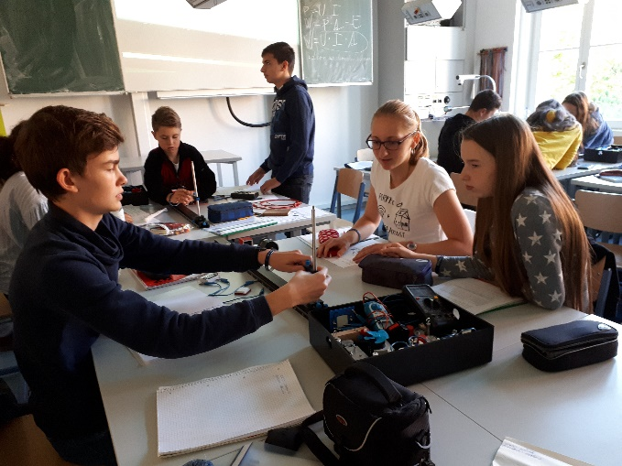
On Monday morning, we met in the physics lab at the Siebold Gymnasium. After we had introduced ourselves, we got original ISS wristbands and made 6 groups in which we worked for the rest of the week. The first task was to find out how effective a heat pump is and how it works. The results of our experiments were quite shocking at first but after a group discussion we came to a conclusion that perpetual motion machine had not been invented, yet. In the afternoon, we went to a boat trip to Veitshöchheim Horticulture and Viticulture Institute. The head of the institute explained how plants can be used to reduce the impacts of global warming in towns and which plants have the right features to do it. In the late evening, we went back to our host families.
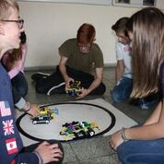
Tuesday started with some experiments testing the efficiency of solar panels. We also climbed to the roof of the school to see the real solar panels in use. After that we watched a documentary about the possible reasons and impacts of global warming, which was made by Leo DiCaprio. After lunch, we went to a guided tour in The Würzburg Residence, which is a UNESCO World Heritage Site. Our English colleagues arrived at the railway station late in the afternoon, so our teams were complete.

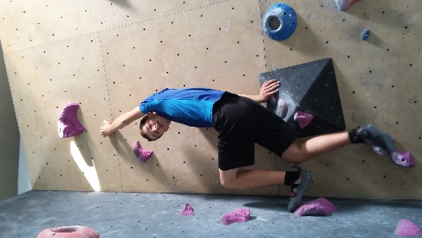
On Wednesday, we were instructed about the basics of robotics and started to build and program our simple robots. First tasks for the robots were quite simple but as the time went on, they got more complex. So we started to solve the tasks using the procedure „Try, fail, reprogram“. In the afternoon we moved from robotics to physical tasks while bowling.

We spent Thursday morning improving not only our communication with robots, but also their design. We taught them how to move in their surroundings with the help of the light and touch sensors. We also programmed them to play a melody while moving. The active afternoon relaxation took place in the boulder centre near Würzburg, where we were sweating profusely while climbing up different tracks from the easy ones to the more difficult ones. We also took part in the climbing contest.

On Friday morning, we were challenged to take part in a robotic competition. The task was to build and program a robot that would push the opponent robot out of a circle marked by a black line not leaving the circle itself. So the Robotic Wars began. After many tests and hours spent reprogramming our robots we put our them to a box ready to use them in the contest on Monday. In the afternoon, we visited three memorials of the last three wars Germany had taken part in. Then we did a lot of sport activities at school, one of them being a witty obstacle course.

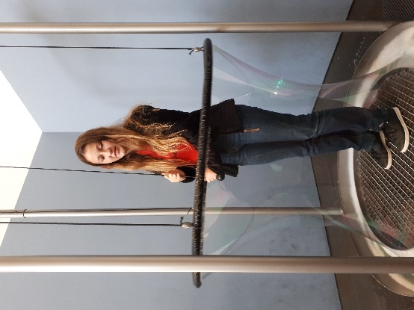
Early in the morning the next day, we met at the railway station and left for Giesen. We visited the Mathematikum there. As the exhibits in the mathematical museum were interactive, the time we had to spend there ran out very quickly. After lunch in the city centre we went to a treasure hunt. During the activity we had to look for some information in different places in the centre of Giesen. That is why we did not need a guide to visit many sights there. We came back to Würzburg late in the evening.

After a relaxing morning with our hosts, we went to a forest near Würzburg. We enjoyed climbing on many different rope tracks high in the trees. Some of the tracks were too difficult but we could bang on handsome instructors who were ready to help us at any time.
As we were carrying our luggage to school the next day, we realized that everything must come to an end. We gathered in the school library where we prepared short presentations about everything we had learnt and experienced during the week. After we had tested our robots in real combats and shared our feelings about the seminar, we were given T-shirts with the logo of Siebold Gymnasium to remind us the nice week we had enjoyed. However, even if we had not been given these nice presents I am sure we will never forget. Then came the sad moments. We had to say good-bye first to our English, and then to our German friends. During the long journey back to Hradec Králové we were sharing the experience of our lives with each other again.

The opening quotation by Kristian Morgenstern got a real meaning after the time spent in Würzburg. Even though we were going home, we were leaving our homes at the same time. Thank you, friends!

