ISS 2017
Shakespeare, Lennon, Newton, Gemmel, Atkinson, Hawking, Elizabeth, Beckham, Lancelot, Holmes... These are some names people usually recall if they hear the word England. Of course there are many more famous Britons who could be mentioned. However, depending on a personal point of view the list of names associated with Great Britain produced by different people would vary a lot.
Six students from Gybon who took part in the traditional ISS seminar this year would most probably start the list with names that are not well-known worldwide (at least not yet). I dare to state that names such as Bel, Adam, Rob, Rachel, Grace, Emily etc. would be right at the top of the list. We cannot but wonder why it is so. To find out the truth you need to ask. I think it is just because the names have influenced their current, personal lives much more than the well known personalities and characters mentioned in the first paragraph. They spent great time with them. They co-operated, had fun, explored how things work, learnt something about cultural and linguistic differences. But most importantly, they have become friends.

On Friday, October 13th, Míša, Bau, Anička, Terka, Marek and Honza set off for a long journey to Lancaster, England. They were full of expectations, tension, nervousness and enthusiasm. They could not wait to meet their colleagues from AKS and Siebold Gymnazium. After a tiring night and day on the coach they finally saw the Irish Sea, which marked the end of the long journey to ISS 2017. Some of them met their hosts at a local bus stop for the first time but most of them hugged their hosts firmly as they had not seen them for a year. So the next seminar began.
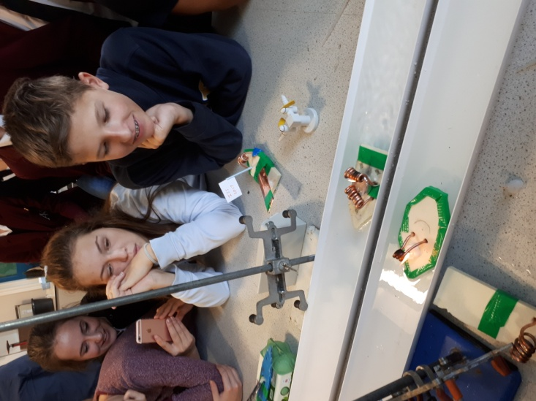
Sunday, seminar day zero, was spent doing various things with the hosts. Some students could be seen in the town exploring the surroundings and having fun in bigger groups. Others stayed with their families, baked cakes, watched movies, took roller coaster rides and practised their speaking skills.
On Monday morning, seminar day one, all ISS students met in the laboratory for the first time to start the practical part of the seminar. Having been put in groups of four (one Czech, one German and two English students each) they did some ice-breaking activities to learn more facts about their colleagues and to cross the language barrier. After that students moved to Blackpool to learn about the area through a visit to Blackpool Tower. They visited the Blackpool Tower Eye, the Ballroom, the Circus and the Dungeons. In the evening they went to a local restaurant to have traditional Fish and Chips. Afterwards they walked along the beach to see the famous illuminations but Ophelia and the sandstorm soon put a stop to that.
On Tuesday students met in the lab to start their first challenge. They were to build a steamboat. They were given a piece of polystyrene, a copper tube, a candle and duck tape. The goal was to explore how to make the most effective, i. e. the fastest, boat. The project was concluded by the final race.
After a delicious lunch in the school dining hall students started to explore sweets. They crushed up different sweets and using chemicals they measured the amount of sugar and acid in “sweet solutions”. In the evening students stayed in school to watch a film during the cinema night.
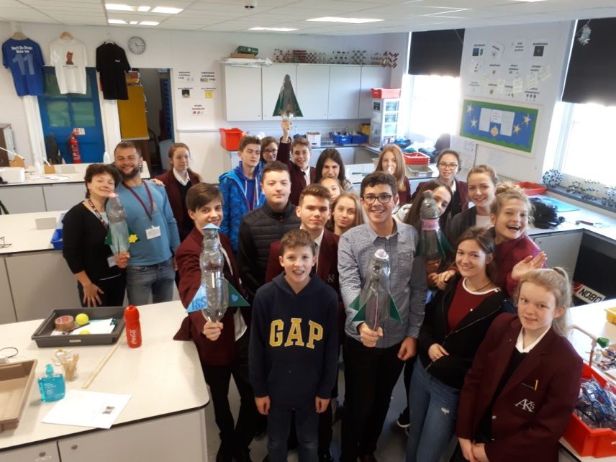
On Wednesday morning students faced another challenge. Their task was to build a rocket made of a plastic bottle filled up with water and air. The goal was to build a rocket that would carry or launch a golf ball that would fall as close to the hole as possible. It was quite hard to find out how many wings/fins an effective rocket should have and how much air and water is needed to fly the rocket a particular distance. The best achievement was a golf ball that landed one meter from the hole that was 70 metres from the launching platform.
In the afternoon students took part in a Murder Mystery challenge. They were given instructions to find out clues that would help them solve the mystery. They explored the local area and learnt a little about local history and architecture.
Thursday, seminar day four, was dedicated to the Lake District. This national park, which is known both for its amazing landscape and literary history, lies in a geologically interesting area. After a boat ride to Glenridding Mr. Winterflood acquainted students with the geological history and formation of this area. Knowing more about different phenomena that form the landscape students went on to visit the famous Aira force waterfall.
The last day of the seminar came much faster than expected. Friday morning was spent on Lytham St. Anne´s Mini Links Golf Course. As Lytham is very popular with golf players, students had the opportunity to try to play this game. Most of them had never played it before so it is no wonder that many balls were lost and some clubs got broken. Despite the cold weather students enjoyed the game of golf and the beautiful view of the sea very much.
After lunch students had an hour to prepare presentations that would reflect and highlight the parts of the seminar that affected them most. In the late afternoon Julian Wild, the founding father of the seminar, and Judith Denver accepted the invitation to watch the presentations. The super positive feedback given by the students via their presentations made it crystal clear that the seminar had been very successful. Having finished their presentations students were given presents and wristbands commemorating another unique year of the legendary seminar.
In the evening everybody met in Ascent Trampoline Park to have fun on trampolines. The joyful moments spent on trampolines ended in a rather sad way as it was the time to say goodbye to our German friends.
Saturday marked the last day of the stay in Lytham St. Annes. Students spend the day with their hosts. At 9 pm they gathered in front of AKS to say farewells to their hosting friends and set off for home.
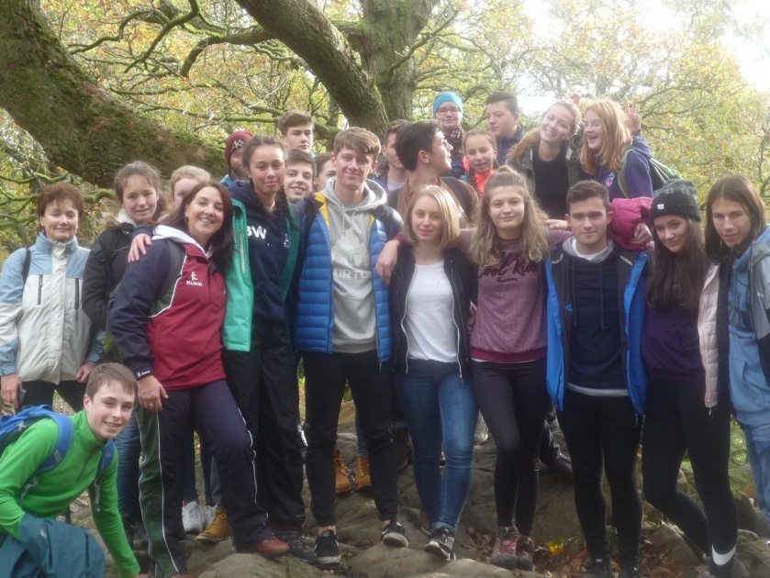
Our students spent the whole Sunday morning sightseeing in the centre of London while they were waiting for the bus connection to Prague. They saw Buckingham Palace, walked across Trafalgar Square, past the Houses of Parliaments and Westminster Abbey. They left for Prague at 11 am and arrived in Hradec Králové 23 hours later. They were exhausted but could not be any happier they had experienced such a wonderful week.
It is hard to realize how much work and effort is put into the seminar every year. Fiona Burnett, Chris Jessop, Norbert Mantel and others spend hours preparing the programme of the seminar every year. However, they know it is worth it. Happy faces and long lasting friendships the seminar helps create are the proof.
Names such as Byron, Voldemort, Churchill shall never be forgot. Names such as Chris, Norbert, Finja, Linus, Islada will stay in our hearts forever...

