ISS 2016
Many things have changed in the past 20 years. The Hubble Space Telescope has snapped fabulous photos of distant galaxies, astrophysicists and astronomers have found many exoplanets in the habitable zone and Curiosity has sent wonderful pictures of the Mars back to the Earth. Michael Jackson, David Bowie, Prince and many others have passed away. The first Afro-American president of the USA has found out he can stroke the last two surviving white rhinoceroses. Great Britain has decided to leave the EU.... However, one thing seems to be stuck solid in the timeline. No matter the climate changes and tricky weather phenomena, every year students from Lytham, Würzburg and Hradec Králové meet to co-operate in the field of science, linguistics, culture and humanity. This year has been no exception.
On Sunday, October 16th, a group of six German students led by Norbert Mantel crossed the western borders of the Czech Republic and finally arrived at Hradec Králové railway station after a ten-hour journey. The tired travellers met their Czech friends, us, and at that point the twentieth International Science Seminar began.
On Monday morning 18 of us set off for our scientific journey. The first day of the seminar was dedicated to light. Having been divided into six groups of four, we started the day by doing optical experiments and ended up making diffracting glasses. At 16:30 we assembled in A-sport Bowling Centre and challenged one another in a game of bowling. Mr. Buršík, a big fan of science and the owner of the centre, provided us with four lanes for free. Then we moved on to the climbing wall where most of us achieved reaching the top for the first time in our lives. Thus the Monday programme finished as late as 20:00.
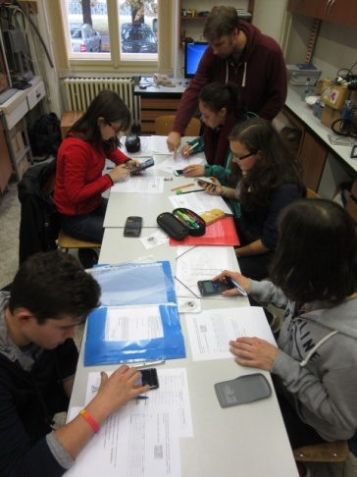
Although the second day of the seminar was announced as the day of darkness, we started the day in our school labs making and using spectrometers. The real darkness came hand-in-hand with our arrival at Josefov Fortress where we learned some facts from the history of the Czech Republic. The day was illuminated by the arrival of our English guests. A group of five English students supervised by Chris Jessop and Fiona Burnett came to Hradec late at night after having visited Police Helicopter Airport in Prague where they learned some interesting facts about police helicopters and were allowed to explore both the interiors and exteriors of the helicopters in detail.
The day of sound could start nowhere else but in the Petrof piano factory. We learnt about the history of making pianos in the Petrof museum and visited the factory itself as well. After a delicious lunch in our school canteen we walked back to school where we measured the speed of sound. The experiments were followed by a concert by the Gybon school choir led by Jaromír Schejbal. To supply our bodies with some motion after the concert we went to play outdoor lasertag in Plachta.
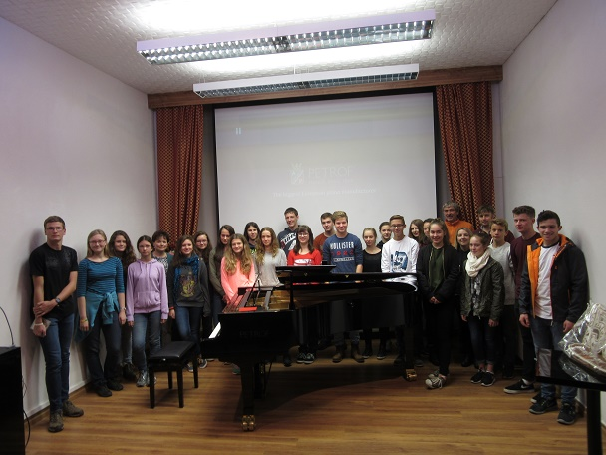
Thursday, the day of stars, started surprisingly with a sport tournament. We were divided into four teams of six players and challenged each other in basketball and floorball. After lunch we went to the local observatory and planetarium where we spent the rest of the afternoon. Jan Veselý started the program with the explanation of Wilson cloud chamber. After that he took us to the brand new planetarium where we were able to move in time, watch stars, visit the planets in our solar system and journey even further into space. Although the weather was too cloudy to watch the sun and stars through the telescope, we learned how it works and watched the highest chimney in the Czech Republic, which is in 50-kilometre-distant Chvaletice power plant, instead.
On Friday, the university day, we met in front of the local landmark, The White Tower. This recently reconstructed historical building enabled us to have a bird´s eye view of the whole town. After we had reached the ground level again, we went to the rector´s office. There we started our guided tour around the Hradec university facilities, ending up in the university labs doing some experiments.
Saturday programme was busy with sightseeing in Prague. After a long journey and even longer queue in front of the safety check, we found ourselves standing in the middle of the largest ancient castle in the world, Prague Castle. St. Vitus Cathedral looked monumental against the sky but it was closed due to a mass. Thus we visited Old Castle, St. George´s Church and the Golden Lane. After a lunch in McDonald´s we went over Charles Bridge to the Old Town Square where we admired the famous Astronomical Clock. Then we proceeded to Wenceslas Square where we could spend our 90 minutes of free time. Tired but full of impressions we came back to Hradec Králové late in the evening.
Sunday was the free day we could spend with our guests and families so the programme was very variable. However, at 17:00 most of us were standing in the ice-hockey stadium supporting our team. Since our guests had never been to an ice-hockey match before, we had to explain the main rules to them. The enthusiasm from the game was growing stronger as our team was scoring more and more goals against Kometa Brno, the leading team in the highest Czech ice-hockey league. After having seen six goals in total, we could go home with a good feeling that our team had beaten Kometa 5:1.
The following day struck as a flash of lightning. Meeting at 7:00 in the physics room we started to realise it was the last day of the seminar. It was up to us to thank everybody who had been supporting the seminar since its beginning 20 years ago. We were especially pleased this year to be joined for the closing ceremony as well as for part of the week by Lytham Headmaster Mike Walton and his wife, visiting the Czech Republic for the first time. Dagmar Dolejší, who had been in charge of the programme for the whole week, awarded each of us a diploma proving we had taken part in this really unique seminar. Each group presented several slides about the seminar reminding us of how wonderful it had been. With a very sad expression on our faces we said goodbye to our German and English friends knowing we will stay in touch forever. Yes, we were sad but could not be any happier we had experienced such a wonderful week.
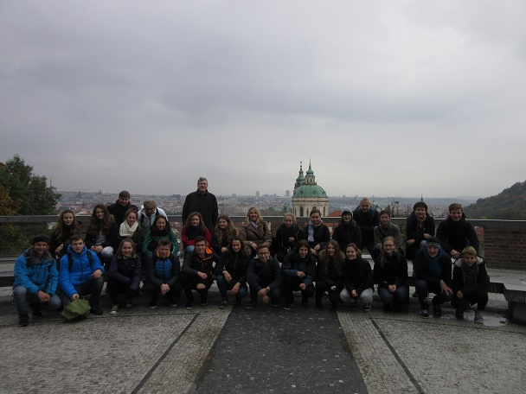
I cannot but wonder how many scientists, friendships and experience the unique ISS seminar has helped to make in past twenty years. Were the students in the previous seminars just as enthusiastic as we were? Or were they even more? Will they ever be again?
Many things have changed since we were born and many things have been slowly changing ever since. Still there are some events that seem to be stuck in time to help people find their way, the right way...
Anička, Petr

